

**SRI KRISHNA COLLEGE OF TECHNOLOGY**

**An Autonomous Institution | Accredited by NAAC with 'A' Grade Affiliated to Anna University | Approved by AICTE**

**KOVAIPUDUR, COIMBATORE 641042**

**E-COMMERCE**

**A PROJECT REPORT**

***Submitted by***

KAWINYA.R **727822TUAM022**

***in partial fulfillment for the award of the degree of***

### BACHELOR OF ENGINEERING IN

**DEPARTMENT OF COMPUTER SCIENCE AND ENGINEERING**

**ARTIFICIAL INTELLLIGENCE AND MACHINE LEARNING**

### JANUARY 2023



**SRI KRISHNA COLLEGE OF TECHNOLOGY**

**An Autonomous Institution | Accredited by NAAC with 'A' Grade Affiliated to Anna University | Approved by AICTE**

**KOVAIPUDUR, COIMBATORE 641042**

**BONAFIDE CERTIFICATE**

Certified that this project report **“e-commerce”** is the bonafide work of **KAWINYA.R** who carried out the project work under my supervision.

#### SIGNATURE SIGNATURE

**Ms.Kavitha Margret.M Dr.R.VIDHYA**

#### SUPERVISOR HEAD OF THE DEPARTMENT

Assistant Professor, Professor,

Department of Computer Science Department of Computer Science

and Engineering and Engineering

Sri Krishna College of Technology, Sri Krishna College of Technology,

Coimbatore-641042. Coimbatore-641042.

Certified that the candidates were examined by us in the Project Work Viva Voce examination held on at Sri Krishna College of Technology, Kovaipudur, Coimbatore -641042

### INTERNAL EXAMINER EXTERNAL EXAMINER

### ACKNOWLEDGEMENT

First and foremost, we thank the **Almighty** for being our light and for showering his gracious blessings throughout the course of this project.

We are grateful to our beloved Dean-Academics **Dr.Manju P &** Dean-Administration **Dr.R.Ramesh Kumar** for their tireless and relentless support.

We extend our sincere thanks to our Head of the Department

**Dr.R.Vidhya** for her encouragement and inspiration.

We are greatly indebted to our Industry Mentor **Mr.Manoj Kumar** & Project guide **Ms.Kavitha Margret.M** Assistant Professor, Department of Computer Science and Engineering for their valuable guidance and suggestions in all aspects that aided us to ameliorate our skills.

We are thankful to all those who have directly and indirectly extended their help to us in completing this project work successfully.

**ABSTRACT**

An online bookshop is a virtual marketplace that enables customers to browse and purchase books from the comfort of their own homes. With the rise of e-commerce, online bookshops have become a popular alternative to traditional brick-and-mortar stores. Customers can easily search for books, read reviews, and make purchases with just a few clicks. Many online bookshops also offer digital books, audiobooks, and other related products. By providing a convenient and user-friendly platform, online bookshops have transformed the way people buy and read books

**TABLE OF CONTENT**

|  |  |  |
| --- | --- | --- |
| **CHAPTER.no** | **TITLE** | **PAGE NO** |
| 1 | INTRODUCTION | 1 |
|  | 1.1 PROBLEM STATEMENT | 2 |
|  | 1.2 OVERVIEW | 2 |
|  | 1.3 OBJECTIVE | 3 |
| 2 | LITERATURE SURVEY | 3 |
| 3 | SYSTEM SPECIFICATIONS | 4 |
| 4 | PROPOSED SYSTEM | 7 |
|  | 4.1 PROPOSED SYSTEM | 7 |
|  | 4.2 ADVANTAGES | 8 |
| 5 | METHODOLOGIES | 9 |
|  | 5.1 LOGIN PAGE | 11 |
|  | 5.2 FORGET PASSWORD | 13 |
|  | 5.4 PRODUCT PAGE | 16 |
| 6 | IMPLEMENTATION AND RESULT | 17 |
| 7 | CONCLUSION AND FUTURE APPLICATION | 48 |
|  | 7.1 CONCLUSION | 49 |
|  | 7.2 FUTURE APPLICATION | 50 |

## 

## CHAPTER-01

## INTRODUCTION

Online book shopping refers to the practice of purchasing books through internet-based platforms. With the advancement of technology and the internet, it has become increasingly popular to buy books online due to its convenience, accessibility, and wide range of options. Online book shopping provides customers with the opportunity to browse through a vast collection of books from the comfort of their own home, compare prices, read reviews, and make purchases with just a few clicks. It has become a convenient and efficient way to buy books, and its popularity is continuously growing. Online shopping is the process whereby consumers directly buy goods, services etc. from a seller interactively in real-time without an intermediary service over the internet.

Online shopping is the process of buying goods and services from merchants who sell on the Internet. Since the emergence of the World Wide Web, merchants have sought to sell their books to people who surf the Internet. Shoppers can visit web stores from the comfort of their homes and shop as they sit in front of the computer. Consumers buy a variety of items from online stores. In fact, people can purchase just about anything from companies that provide their books online. Books, clothing, household appliances, toys, hardware, software, and health insurance are just some of the hundreds of books consumers can buy from an online store.

### PROBLEM STATEMENT

Despite the convenience and accessibility of online book shopping, customers are facing issues with the user interface, the limited availability of certain titles, slow delivery times, and the lack of personalized recommendations. As a result, customers may be discouraged from using the platform, leading to decreased sales and lower customer satisfaction. The goal is to improve the user experience, increase the variety of titles available, shorten delivery times, and implement personalized recommendation systems to enhance customer satisfaction and increase sales.

### OVERVIEW

An online book shopping website is a digital platform that enables customers to browse, purchase and receive books online. It typically offers a wide range of books, from popular fiction and non-fiction titles to academic and professional texts, as well as e-books and audiobooks. The website provides users with a user-friendly interface, easy search and filtering options, and secure payment gateways for transactions. The website may also offer additional features such as customer reviews and ratings, author interviews, and personalized book recommendations. In addition, the website may offer various shipping options and provide tracking services to ensure timely and secure delivery. The overall goal of an online book shopping website is to provide a convenient and efficient shopping experience for customers while offering a vast selection of books and

additional features to enhance customer satisfaction.

### OBJECTIVE

Provide a user-friendly interface and efficient search options for customers to easily find and purchase books. Offer a wide range of book titles, including new releases and popular titles, to satisfy the diverse needs of customers. Provide customers with a secure payment gateway and ensure the privacy of their personal and financial information. Offer personalized book recommendations and relevant promotions to enhance customer satisfaction and loyalty. Provide transparent and reliable information on delivery options, shipping fees, and delivery times to ensure timely and secure delivery .Enable customers to provide feedback through ratings and reviews to enhance the transparency and credibility of the website .Continuously improve the website's features and user experience to meet customer expectations and increase sales. Ensure the website is accessible and easy to navigate for customers with disabilities, as well as for users with limited internet connectivity or older devices. My objective is to design such an application using which one can say 'goodbye' to the days when you stood in line waiting, and waiting some more for a store clerk to finally check out your items. Online shopping transactions occur instantly-saving you time to get your other errands done! Additionally, unlike a store, online shopping has friendly customer service representatives available 24 hours a day, 7 days a week to assist you with locating, purchasing and shipping your merchandise.

My main aim is to design such a book store where customer can visit our site anytime of the day from anywhere to view the available books, choose any of them and can order by paying online or can opt for cash on delivery as well. The administrator will regularly add any new books available to them for sale. The administrator will take books from the reputed publishers and vendor only.

**CHAPTER 02**

**LITERATURE SURVEY**

### 2.1 RELATED WORKS

Amazon Books - a popular online book shopping platform that offers a wide range of books, including e-books and audiobooks. It provides personalized recommendations, customer reviews, and fast delivery options.

Barnes & Noble - another well-known online book shopping website that offers a wide range of books, e-books, and audiobooks. It also provides personalized recommendations and free shipping for orders over a certain amount.

Goodreads - a social network for book lovers that offers book recommendations, reviews, and ratings. It allows users to track their reading progress and connect with other readers.

Book Depository - an online bookstore that offers free worldwide delivery and a wide range of book titles. It provides customer reviews, book recommendations, and a user-friendly interface.

Google Books - an online platform that offers access to a vast collection of books, including free books and previews of paid books. It allows users to search for specific topics, view book details, and make purchases.

These examples represent a few of the most popular and successful online book shopping platforms, each with their unique strengths and features.

## CHAPTER 3

## SYSTEM SPECIFICATION

In this chapter, we are gonna see the softwares that we have used to build the website. This chapter gives you a small description about the softwares used in the project.

### 3.1 VS CODE

Visual Studio Code is a source code editor developed by Microsoft for Windows, Linux, and macOS. It includes support for debugging, embedded Git control, syntax highlighting, intelligent code completion, snippets, and code refactoring. It is also customizable, so users can change the editor's theme, keyboard shortcuts, and preferences.

VS Code is an excellent code editor for React projects. It is lightweight, customizable, and has a wide range of features that make it ideal for React development. It has built-in support for JavaScript, JSX, and TypeScript, and enables developers to quickly move between files and view detailed type definitions. It also has a built-in terminal for running tasks. Additionally, VS Code has an extensive library of extensions that allow developers to quickly add features like code snippets, debugging tools, and linting support to their projects.

**3.2 HTML**

HTML or HyperText Markup Language is the standard markup language used to create web pages.

HTML is written in the form of HTML elements consisting of tags enclosed in angle brackets (like <html>). HTML tags most commonly come in pairs like <h1> and </h1>, although some tags represent empty elements and so are unpaired, for example <img>. The first tag in a pair is the start tag, and the second tag is the end tag (they are also called opening tags and closing tags).

The purpose of a web browser is to read HTML documents and compose them into visible or audible web pages. The browser does not display the HTML tags, but uses the tags to interpret the content of the page. HTML describes the structure of a website semantically along with cues for presentation, making it a markup language rather than a programming language.

HTML elements form the building blocks of all websites. HTML allows images and objects to be embedded and can be used to create interactive forms. It provides a means to create structured documents by denoting structural semantics for text such as headings, paragraphs, lists, links, quotes and other items. It can embed scripts written in languages such as JavaScript which affect the behavior of HTML web pages.

**3.3 CSS**

CSS was first developed in 1997, as a way for Web developers to define the look and feel of their Web pages. It was intended to allow developers to separate content from design so that HTML could perform more of the function that it was originally based on the markup of content, without worry about the design and layout.

CSS didn't gain in popularity until around 2000, when Web browsers began using more than the basic font and color aspects of CSS.

Web Designers that don't use CSS for their design and development of Web sites are rapidly becoming a thing of the past. And it is arguably as important to understand CSS as it is to know HTML - and some would say it was more important to know CSS.

Style sheet refers to the document itself. Style sheets have been used for document design for years. They are the technical specifications for a layout, whether print or online. Print designers use style sheets to insure that their designs are printed exactly to specifications. A style sheet for a Web page serves the same purpose, but with the added functionality of also telling the viewing engine (the Web browser) how to render the document being viewed.

**CHAPTER 04**

**PROPOSED SYSTEM**

This chapter gives a small description about the proposed idea behind the development of our website

### PROPOSED SYSTEM

User interface - a user-friendly and visually appealing interface that allows customers to browse books, search for specific titles or authors, and easily make purchases.

Book inventory - a comprehensive inventory of books that includes a wide range of titles, genres, and formats (e-books, audiobooks, etc.) to satisfy the diverse needs of customers.

Personalization - a recommendation system that provides personalized book recommendations based on customers' browsing and purchase history, as well as their ratings and reviews.

Security - a secure payment gateway that ensures the privacy and safety of customers' personal and financial information.

Delivery options - various delivery options, including standard and expedited shipping, as well as tracking services to ensure timely and secure delivery.

Customer support - a customer support system that provides assistance with any issues or questions related to the shopping experience.

Accessibility - an accessible website that meets web accessibility standards to ensure that all customers, including those with disabilities, can easily access and use the platform.

Feedback system - a feedback system that allows customers to leave ratings and reviews to provide transparency and credibility to the website.

Overall, this proposed system aims to provide a convenient, efficient, and personalized shopping experience for customers while ensuring the security and privacy of their personal and financial information.

### ADVANTAGES

There are several advantages of online book shopping, including:

Convenience: Customers can easily browse and purchase books from the comfort of their own home, without the need to physically visit a bookstore.

Availability: Online bookstores offer a vast collection of books, including rare and hard-to-find titles that may not be available in physical bookstores.

Accessibility: Online bookstores are accessible 24/7, allowing customers to make purchases at any time of day or night.

Price comparison: Online bookstores allow customers to easily compare prices across multiple websites, ensuring that they get the best deal.

Personalization: Online bookstores often provide personalized book recommendations based on customers' browsing and purchase history, increasing the likelihood that they will find books they enjoy.

Reviews: Online bookstores often provide customer reviews and ratings, allowing customers to make informed decisions about their purchases.

Fast delivery: Many online bookstores offer fast delivery options, ensuring that customers receive their books in a timely manner.

Environmental impact: Online bookstores can be more environmentally friendly than physical bookstores since they don't require the use of paper catalogs or transportation to a physical location.

Overall, online book shopping offers customers a convenient, accessible, and personalized shopping experience with a wide selection of books and competitive pricing.

## CHAPTER 5 METHODOLOGIES

This chapter gives a small description about how our system works.

### 5.1.LOGIN

In this page we will be asking about the username and password of the user. Firstly the website validates the user inputs. It verifies the username and password by checking it with the usernames and passwords stored in the local storage when the user creates an account in the website.

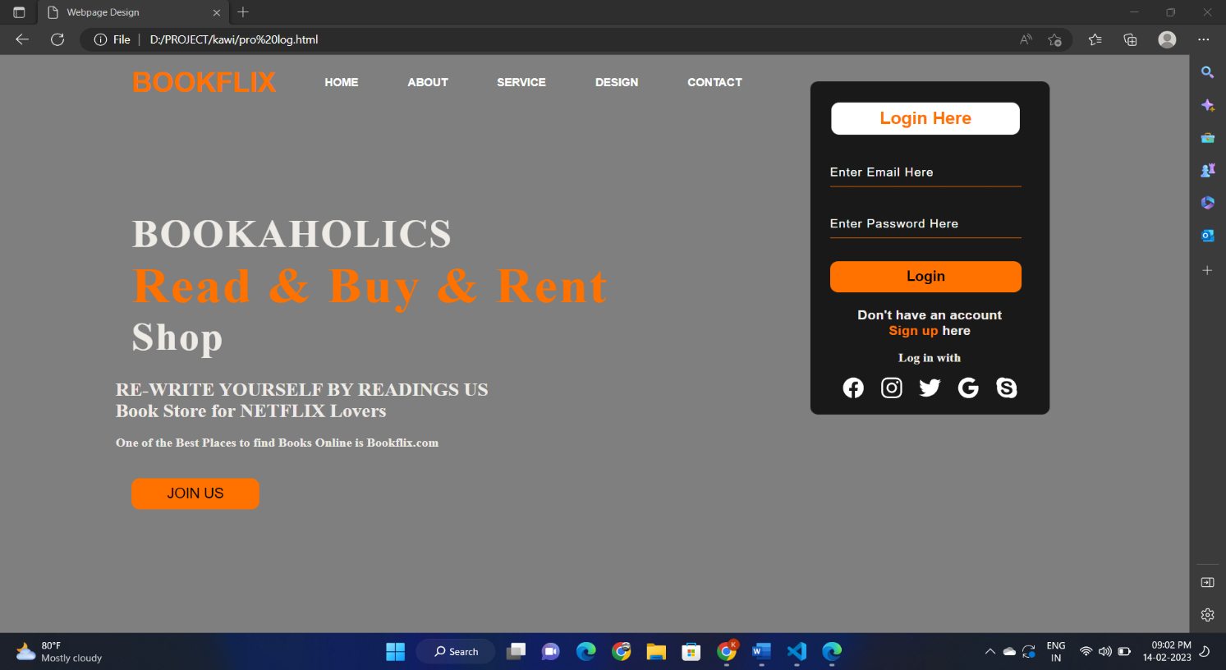

### FORGOT PASSWORD

If an existing user forgets the password he can access a component named forgot password where he will be directed for a page that’s requesting their email id, after entering the existing email id the user will be redirected to the email OTP verification, then the user can change their password.

### PRODUCTS PAGE

This page displays the list of products available for sale. These details have been displayed from the list of products available in the javascript file named data.js. So that if we want to add some products to a particular product we can easily do it by adding the details to the products js file.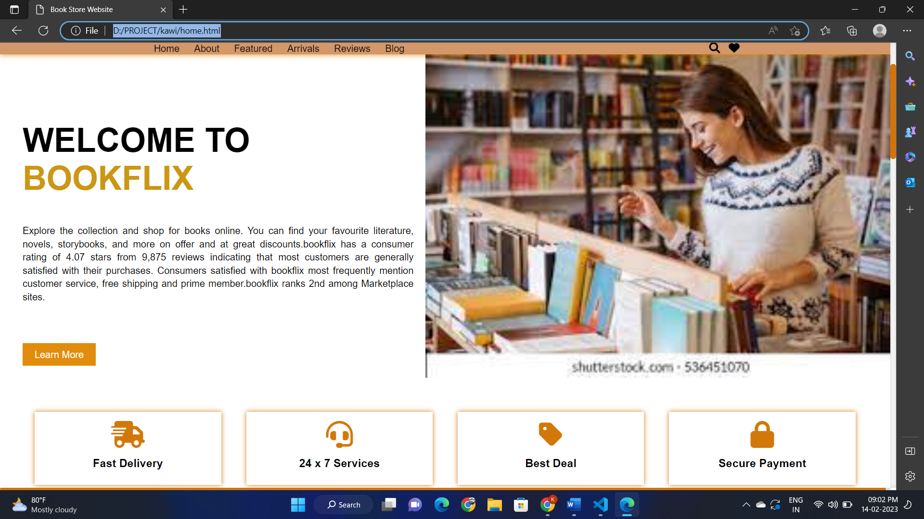

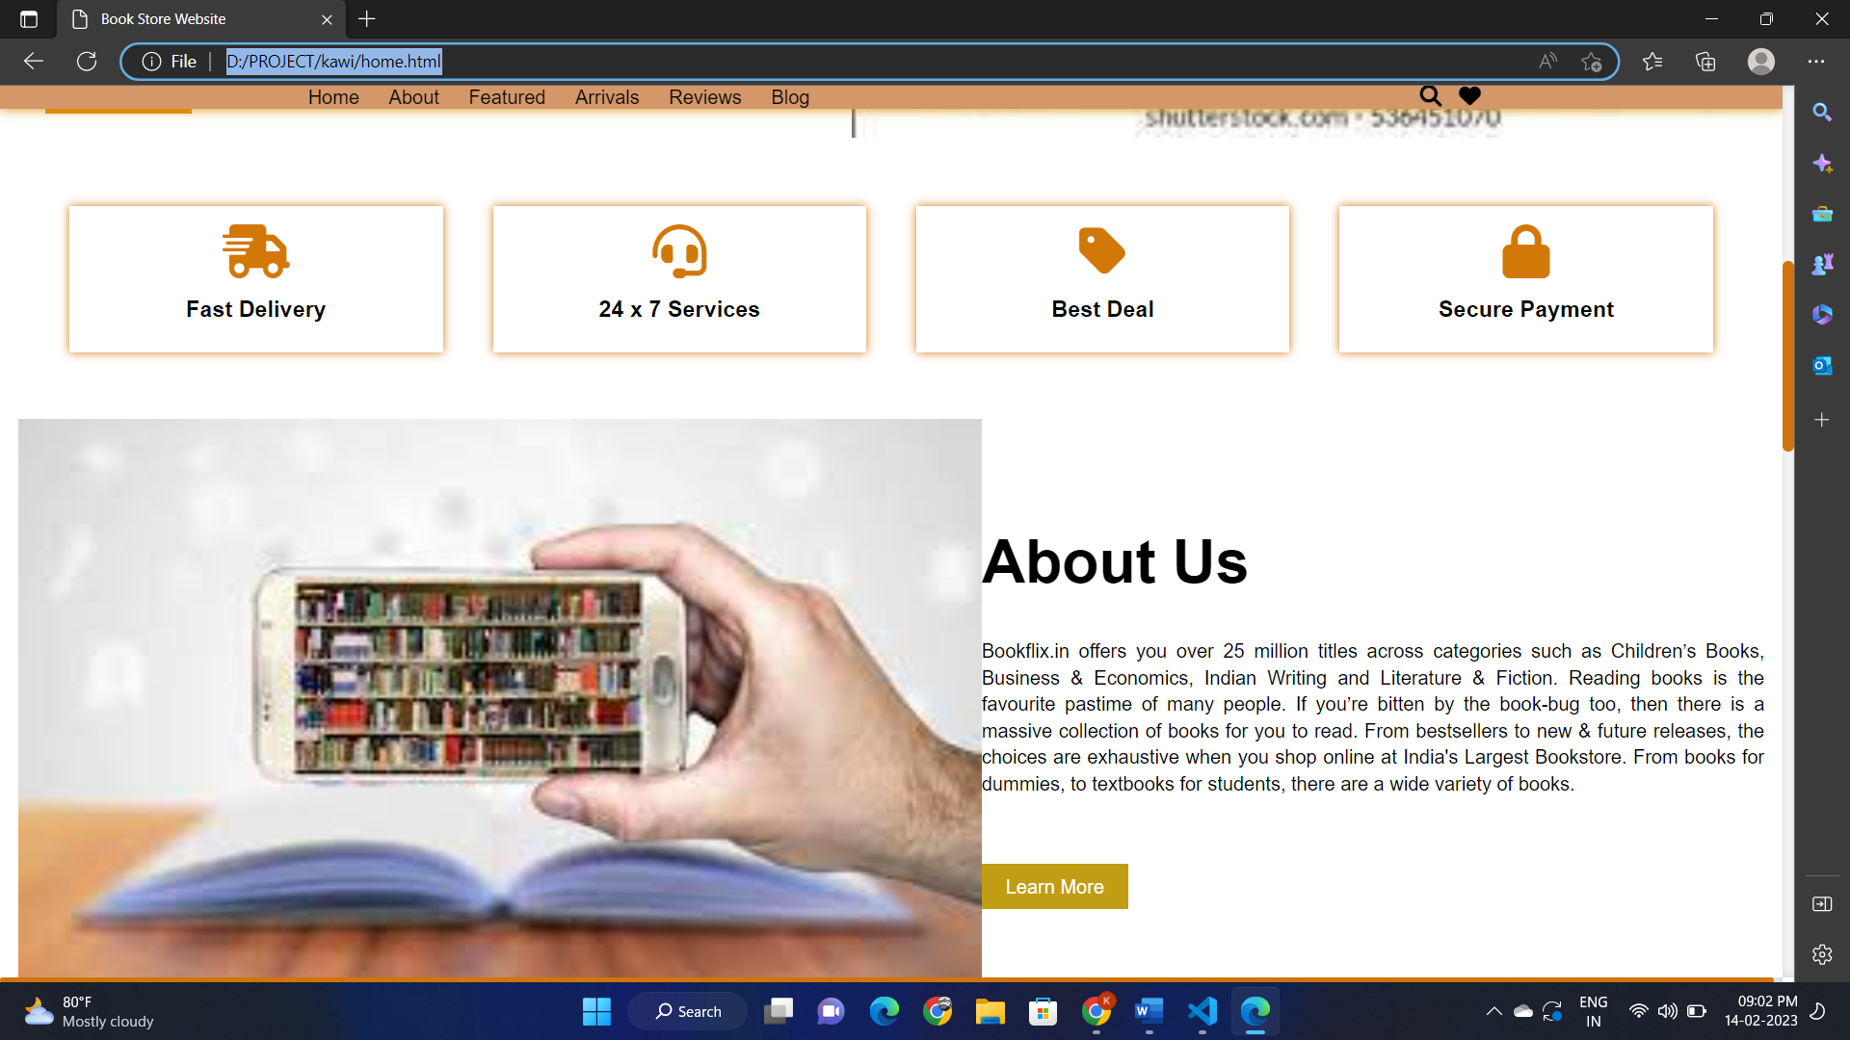

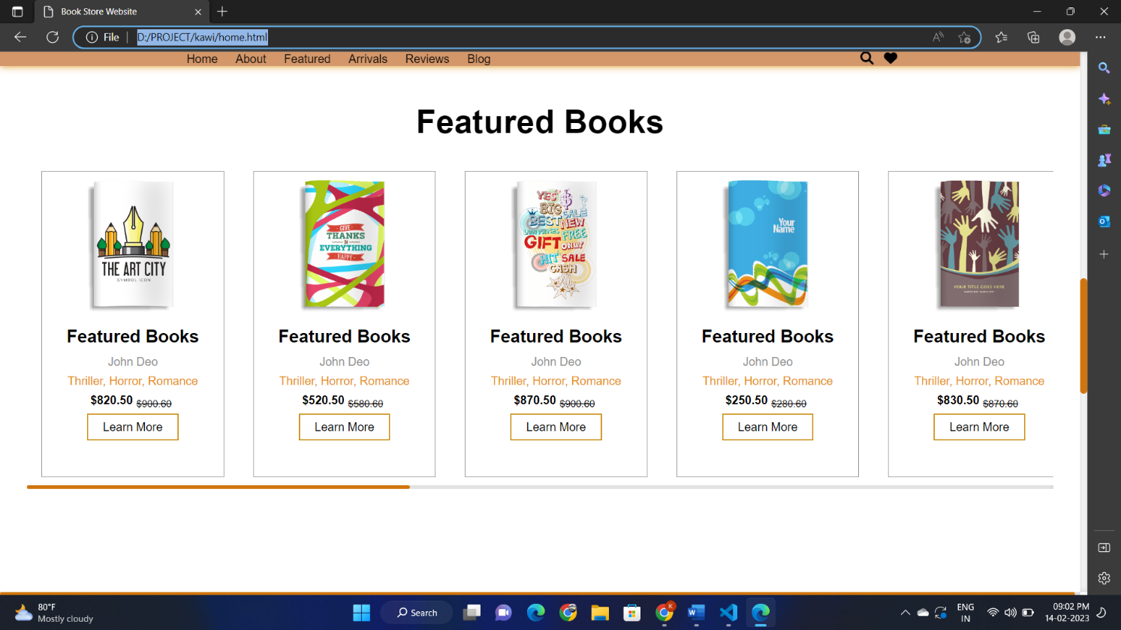

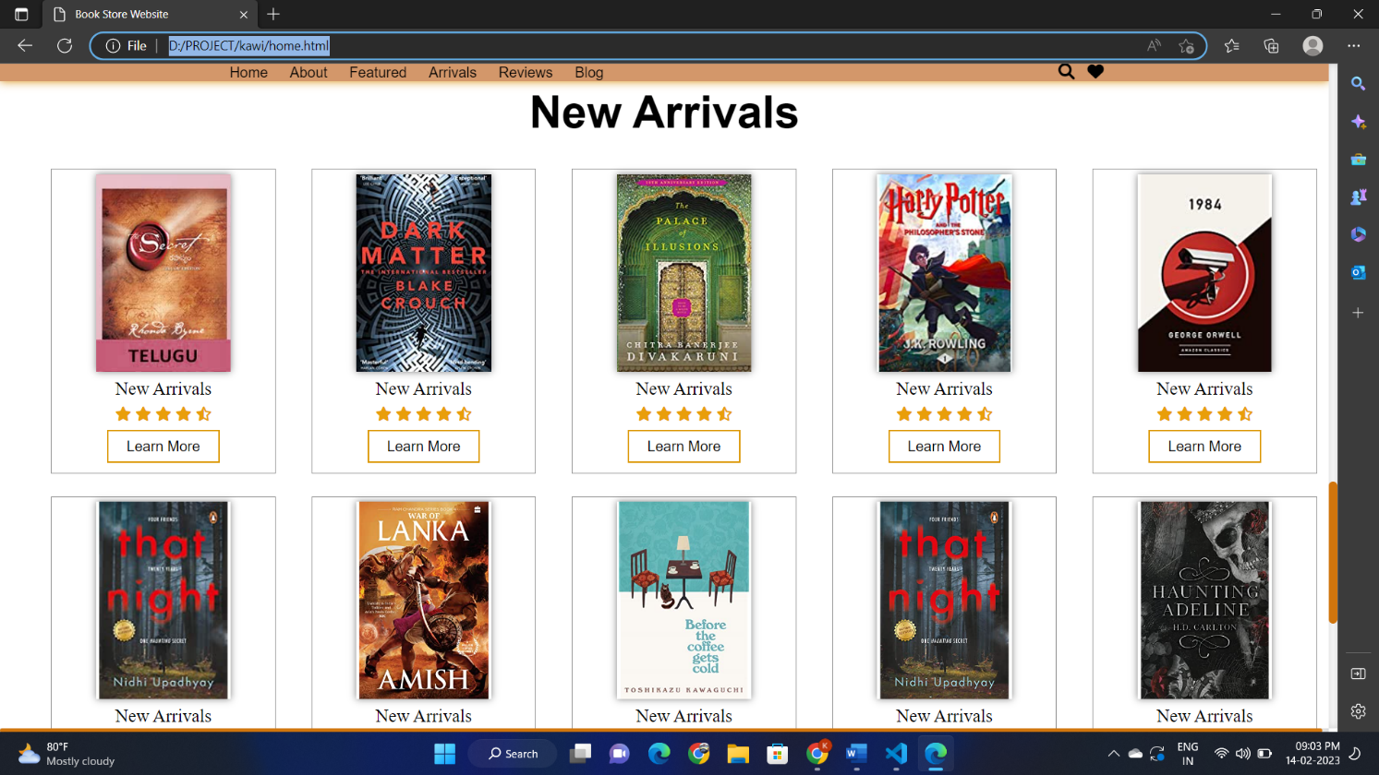

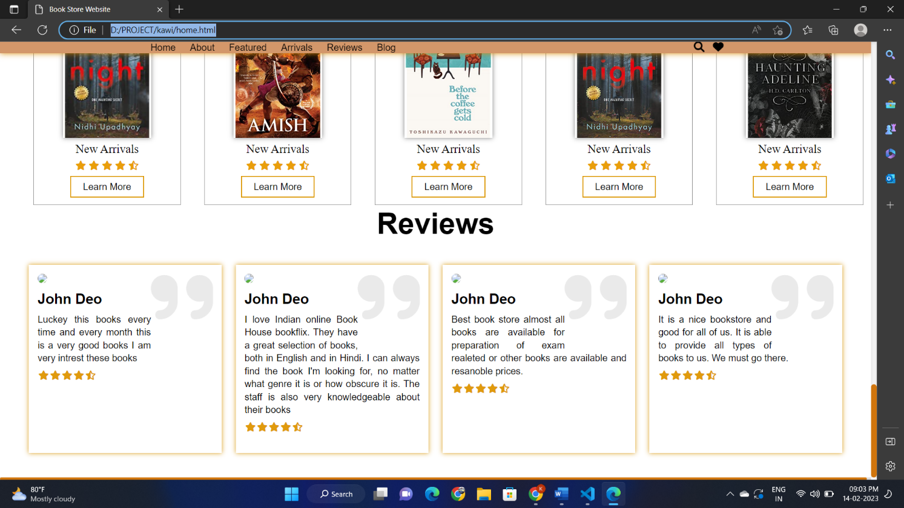

* 1. **CONTACT PAGE**

The contact page for an online book shopping website should include the following information:

**Contact form**: A form that allows customers to send a message directly to the website's customer service team.

**Email address**: An email address that customers can use to contact the website's customer service team.

**Phone number**: A phone number that customers can call if they need immediate assistance.

**Mailing address**: The website's physical mailing address for customers who prefer to send letters or documents through mail.

**Social media links**: Links to the website's social media accounts so that customers can connect with the website on various social media platforms.

**Frequently Asked Questions (FAQs):** A section that addresses the most common questions customers may have, which could help reduce the number of inquiries received by the customer service team.

1. 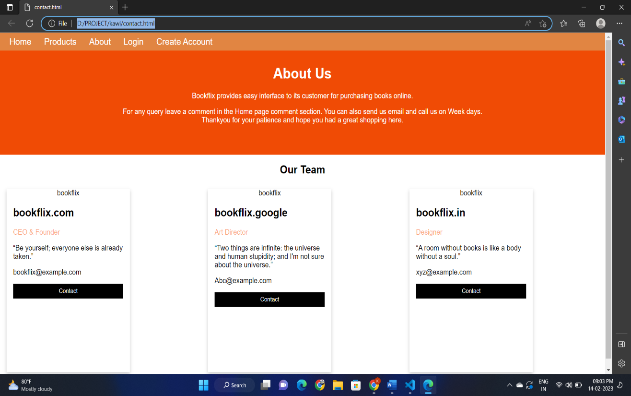

### 6.7.CODING

LOGIN:

<!DOCTYPE html>

<html lang="en">

<head>

    <title>Webpage Design</title>

    <link rel="stylesheet" href="style.css">

</head>

<body>

    <div class="main">

        <div class="navbar">

            <div class="icon">

                <h2 class="logo">BOOKFLIX</h2>

            </div>

            <div class="menu">

                <ul>

                    <li><a href="#">HOME</a></li>

                    <li><a href="#">ABOUT</a></li>

                    <li><a href="#">SERVICE</a></li>

                    <li><a href="#">DESIGN</a></li>

                    <li><a href="#">CONTACT</a></li>

                </ul>

            </div>

        </div>

        <div class="content"><br>

            <h1>BOOKAHOLICS<br><span>Read & Buy & Rent</span> <br>Shop</h1>

            <p class="par"><h2><b>RE-WRITE YOURSELF BY READINGS US <br>

                Book Store for NETFLIX Lovers<b></h2></p>

                <br>  One of the Best Places to find Books Online is Bookflix.com</p><br>

                <br>

                <button class="cn"><a href="#">JOIN US</a></button>

                <br>

                <div class="form">

                    <h2>Login Here</h2>

                    <input type="email" name="email" placeholder="Enter Email Here">

                    <input type="password" name="" placeholder="Enter Password Here">

                    <button class="btnn"><a href="#">Login</a></button>

                    <p class="link">Don't have an account<br>

                    <a href="#">Sign up </a> here</a></p>

                    <p class="liw">Log in with</p>

                    <div class="icons">

                        <a href="#"><ion-icon name="logo-facebook"></ion-icon></a>

                        <a href="#"><ion-icon name="logo-instagram"></ion-icon></a>

                        <a href="#"><ion-icon name="logo-twitter"></ion-icon></a>

                        <a href="#"><ion-icon name="logo-google"></ion-icon></a>

                        <a href="#"><ion-icon name="logo-skype"></ion-icon></a>

                    </div>

                </div>

                    </div>

                </div>

        </div>

    </div>

    <script src="https://unpkg.com/ionicons@5.4.0/dist/ionicons.js"></script>

</body>

</html>

*{

    margin: 0;

    padding: 0;

}

.main{

    width: 100%;

    background: linear-gradient(to top, rgba(0,0,0,0.5)50%,rgba(0,0,0,0.5)50%), url(1.jpg);

    background-position: center;

    background-size: cover;

    height: 100vh;

}

.navbar{

    width: 1200px;

    height: 75px;

    margin: auto;

}

.icon{

    width: 200px;

    float: left;

    height: 70px;

}

.logo{

    color: #ff7200;

    font-size: 35px;

    font-family: Arial;

    padding-left: 20px;

    float: left;

    padding-top: 10px;

    margin-top: 5px

}

.menu{

    width: 400px;

    float: left;

    height: 70px;

}

ul{

    float: left;

    display: flex;

    justify-content: center;

    align-items: center;

}

ul li{

    list-style: none;

    margin-left: 62px;

    margin-top: 27px;

    font-size: 14px;

}

ul li a{

    text-decoration: none;

    color: #fff;

    font-family: Arial;

    font-weight: bold;

    transition: 0.4s ease-in-out;

}

ul li a:hover{

    color: #ff7200;

}

.search{

    width: 330px;

    float: left;

    margin-left: 270px;

}

.srch{

    font-family: 'Times New Roman';

    width: 200px;

    height: 40px;

    background: transparent;

    border: 1px solid #ff7200;

    margin-top: 13px;

    color: #fff;

    border-right: none;

    font-size: 16px;

    float: left;

    padding: 10px;

    border-bottom-left-radius: 5px;

    border-top-left-radius: 5px;

}

.btn{

    width: 100px;

    height: 40px;

    background: #ff7200;

    border: 2px solid #ff7200;

    margin-top: 13px;

    color: rgb(252, 160, 12);

    font-size: 15px;

    border-bottom-right-radius: 5px;

    border-bottom-right-radius: 5px;

    transition: 0.2s ease;

    cursor: pointer;

}

.btn:hover{

    color: #000;

}

.btn:focus{

    outline: none;

}

.srch:focus{

    outline: none;

}

.content{

    width: 1200px;

    height: auto;

    margin: auto;

    color: rgb(238, 235, 231);

    position: relative;

}

.content .par{

    padding-left: 20px;

    padding-bottom: 25px;

    font-family: Arial;

    letter-spacing: 1.2px;

    line-height: 30px;

}

.content h1{

    font-family: 'Times New Roman';

    font-size: 50px;

    padding-left: 20px;

    margin-top: 9%;

    letter-spacing: 2px;

}

.content .cn{

    width: 160px;

    height: 40px;

    background: #ff7200;

    border: none;

    margin-bottom: 10px;

    margin-left: 20px;

    font-size: 18px;

    border-radius: 10px;

    cursor: pointer;

    transition: .4s ease;

}

.content .cn a{

    text-decoration: none;

    color: #000;

    transition: .3s ease;

}

.cn:hover{

    background-color: #fff;

}

.content span{

    color: #ff7200;

    font-size: 65px

}

.form{

    width: 250px;

    height: 380px;

    background: linear-gradient(to top, rgba(0,0,0,0.8)50%,rgba(0,0,0,0.8)50%);

    position: absolute;

    top: -20px;

    left: 870px;

    transform: translate(0%,-5%);

    border-radius: 10px;

    padding: 25px;

}

.form h2{

    width: 220px;

    font-family: sans-serif;

    text-align: center;

    color: #ff7200;

    font-size: 22px;

    background-color: #fff;

    border-radius: 10px;

    margin: 2px;

    padding: 8px;

}

.form input{

    width: 240px;

    height: 35px;

    background: transparent;

    border-bottom: 1px solid #ff7200;

    border-top: none;

    border-right: none;

    border-left: none;

    color: #fff;

    font-size: 15px;

    letter-spacing: 1px;

    margin-top: 30px;

    font-family: sans-serif;

}

.form input:focus{

    outline: none;

}

::placeholder{

    color: #fff;

    font-family: Arial;

}

.btnn{

    width: 240px;

    height: 40px;

    background: #ff7200;

    border: none;

    margin-top: 30px;

    font-size: 18px;

    border-radius: 10px;

    cursor: pointer;

    color: #fff;

    transition: 0.4s ease;

}

.btnn:hover{

    background: #fff;

    color: #ff7200;

}

.btnn a{

    text-decoration: none;

    color: #000;

    font-weight: bold;

}

.form .link{

    font-family: Arial, Helvetica, sans-serif;

    font-size: 17px;

    padding-top: 20px;

    text-align: center;

}

.form .link a{

    text-decoration: none;

    color: #ff7200;

}

.liw{

    padding-top: 15px;

    padding-bottom: 10px;

    text-align: center;

}

.icons a{

    text-decoration: none;

    color: #fff;

}

.icons ion-icon{

    color: #fff;

    font-size: 30px;

    padding-left: 14px;

    padding-top: 5px;

    transition: 0.3s ease;

}

.icons ion-icon:hover{

    color: #ff7200;

}

**PRODUCT PAGE:**

<!DOCTYPE html>

<html lang="en">

<head>

    <meta charset="UTF-8">

    <meta http-equiv="X-UA-Compatible" content="IE=edge">

    <meta name="viewport" content="width=device-width, initial-scale=1.0">

    <title>Book Store Website</title>

    <link rel="stylesheet" href="style1.css">

    <link rel="stylesheet" href="https://cdnjs.cloudflare.com/ajax/libs/font-awesome/6.1.1/css/all.min.css" integrity="sha512-KfkfwYDsLkIlwQp6LFnl8zNdLGxu9YAA1QvwINks4PhcElQSvqcyVLLD9aMhXd13uQjoXtEKNosOWaZqXgel0g==" crossorigin="anonymous" referrerpolicy="no-referrer" />

</head>

<body>

    <section>

        <nav>

            <ul>

                <li><a href="#Home">Home</a></li>

                <li><a href="#About">About</a></li>

                <li><a href="#Featured">Featured</a></li>

                <li><a href="#Arrivals">Arrivals</a></li>

                <li><a href="#Reviews">Reviews</a></li>

                <li><a href="#Blog">Blog</a></li>

            </ul>

            <div class="social_icon">

                <i class="fa-solid fa-magnifying-glass"></i>

                <i class="fa-solid fa-heart"></i>

            </div>

        </nav>

        <div class="main">

            <div class="main_tag">

                <h1>WELCOME TO<br><span>BOOKFLIX</span></h1>

                <p>

                    Explore the collection and shop for books online. You can find your

                    favourite literature, novels, storybooks, and more on offer and at great discounts.bookflix has a consumer rating of

                    4.07 stars from 9,875 reviews indicating that most customers are generally satisfied with their purchases. Consumers satisfied with

                     bookflix most frequently mention customer service,

                    free shipping and prime member.bookflix ranks 2nd among Marketplace sites.

                </p>

                <a href="#" class="main_btn">Learn More</a>

            </div>

            <div class="main_img">

                <img src="D:\PROJECT\img\1111.jfif">

            </div>

        </div>

    </section>

    <!--Services-->

    <div class="services">

        <div class="services_box">

            <div class="services_card">

                <i class="fa-solid fa-truck-fast"></i>

                <h3>Fast Delivery</h3>

            </div>

            <div class="services_card">

                <i class="fa-solid fa-headset"></i>

                <h3>24 x 7 Services</h3>

            </div>

            <div class="services_card">

                <i class="fa-solid fa-tag"></i>

                <h3>Best Deal</h3>

            </div>

            <div class="services_card">

                <i class="fa-solid fa-lock"></i>

                <h3>Secure Payment</h3>

            </div>

        </div>

    </div>

    <!--About-->

    <div class="about">

        <div class="about_image">

            <img src="D:\PROJECT\img\ugfj.jfif">

        </div>

        <div class="about_tag">

            <h1>About Us</h1>

            <p>

                Bookflix.in offers you over 25 million titles across categories such as Children’s Books, Business & Economics, Indian Writing and Literature & Fiction.

                Reading books is the favourite pastime of many people. If you’re bitten by the book-bug too, then there is a massive collection of books for you to read. From bestsellers to new & future releases, the choices are exhaustive when you shop online at India's Largest Bookstore.

                From books for dummies, to textbooks for students, there are a wide variety of books.

            </p>

            <a href="#" class="about_btn">Learn More</a>

        </div>

    </div>

    <!--Books-->

    <div class="featured_boks">

        <h1>Featured Books</h1>

        <div class="featured_book_box">

            <div class="featured_book_card">

                <div class="featurde_book_img">

                    <img src="D:\PROJECT\img\book-1.png">

                </div>

                <div class="featurde_book_tag">

                    <h2>Featured Books</h2>

                    <p class="writer">John Deo</p>

                    <div class="categories">Thriller, Horror, Romance</div>

                    <p class="book_price">$820.50<sub><del>$900.60</del></sub></p>

                    <a href="#" class="f_btn">Learn More</a>

                </div>

            </div>

            <div class="featured_book_card">

                <div class="featurde_book_img">

                    <img src="D:\PROJECT\img\book-2.png">

                </div>

                <div class="featurde_book_tag">

                    <h2>Featured Books</h2>

                    <p class="writer">John Deo</p>

                    <div class="categories">Thriller, Horror, Romance</div>

                    <p class="book_price">$520.50<sub><del>$580.60</del></sub></p>

                    <a href="#" class="f_btn">Learn More</a>

                </div>

            </div>

            <div class="featured_book_card">

                <div class="featurde_book_img">

                    <img src="D:\PROJECT\img\book3.png">

                </div>

                <div class="featurde_book_tag">

                    <h2>Featured Books</h2>

                    <p class="writer">John Deo</p>

                    <div class="categories">Thriller, Horror, Romance</div>

                    <p class="book_price">$870.50<sub><del>$900.60</del></sub></p>

                    <a href="#" class="f_btn">Learn More</a>

                </div>

            </div>

            <div class="featured_book_card">

                <div class="featurde_book_img">

                    <img src="D:\PROJECT\img\book-3.png">

                </div>

                <div class="featurde_book_tag">

                    <h2>Featured Books</h2>

                    <p class="writer">John Deo</p>

                    <div class="categories">Thriller, Horror, Romance</div>

                    <p class="book_price">$250.50<sub><del>$280.60</del></sub></p>

                    <a href="#" class="f_btn">Learn More</a>

                </div>

            </div>

            <div class="featured_book_card">

                <div class="featurde_book_img">

                    <img src="D:\PROJECT\img\book-4.png">

                </div>

                <div class="featurde_book_tag">

                    <h2>Featured Books</h2>

                    <p class="writer">John Deo</p>

                    <div class="categories">Thriller, Horror, Romance</div>

                    <p class="book_price">$830.50<sub><del>$870.60</del></sub></p>

                    <a href="#" class="f_btn">Learn More</a>

                </div>

            </div>

            <div class="featured_book_card">

                <div class="featurde_book_img">

                    <img src="D:\PROJECT\img\book5.png">

                </div>

                <div class="featurde_book_tag">

                    <h2>Featured Books</h2>

                    <p class="writer">John Deo</p>

                    <div class="categories">Thriller, Horror, Romance</div>

                    <p class="book_price">$250.50<sub><del>$280.60</del></sub></p>

                    <a href="#" class="f_btn">Learn More</a>

                </div>

            </div>

            <div class="featured_book_card">

                <div class="featurde_book_img">

                    <img src="D:\PROJECT\img\book-5.png">

                </div>

                <div class="featurde_book_tag">

                    <h2>Featured Books</h2>

                    <p class="writer">John Deo</p>

                    <div class="categories">Thriller, Horror, Romance</div>

                    <p class="book_price">$2500.50<sub><del>$2800.60</del></sub></p>

                    <a href="#" class="f_btn">Learn More</a>

                </div>

            </div>

            <div class="featured_book_card">

                <div class="featurde_book_img">

                    <img src="D:\PROJECT\img\book-6.png">

                </div>

                <div class="featurde_book_tag">

                    <h2>Featured Books</h2>

                    <p class="writer">John Deo</p>

                    <div class="categories">Thriller, Horror, Romance</div>

                    <p class="book_price">$580.50<sub><del>$680.60</del></sub></p>

                    <a href="#" class="f_btn">Learn More</a>

                </div>

            </div>

            <div class="featured_book_card">

                <div class="featurde_book_img">

                    <img src="D:\PROJECT\img\book7.png">

                </div>

                <div class="featurde_book_tag">

                    <h2>Featured Books</h2>

                    <p class="writer">John Deo</p>

                    <div class="categories">Thriller, Horror, Romance</div>

                    <p class="book_price">$25.50<sub><del>$28.60</del></sub></p>

                    <a href="#" class="f_btn">Learn More</a>

                </div>

            </div>

            <div class="featured_book_card">

                <div class="featurde_book_img">

                    <img src="D:\PROJECT\img\book-7.png">

                </div>

                <div class="featurde_book_tag">

                    <h2>Featured Books</h2>

                    <p class="writer">John Deo</p>

                    <div class="categories">Thriller, Horror, Romance</div>

                    <p class="book_price">$550.50<sub><del>$1280.60</del></sub></p>

                    <a href="#" class="f_btn">Learn More</a>

                </div>

            </div>

            <div class="featured_book_card">

                <div class="featurde_book_img">

                    <img src="D:\PROJECT\img\book-8.png">

                </div>

                <div class="featurde_book_tag">

                    <h2>Featured Books</h2>

                    <p class="writer">John Deo</p>

                    <div class="categories">Thriller, Horror, Romance</div>

                    <p class="book_price">$255.50<sub><del>$280.60</del></sub></p>

                    <a href="#" class="f_btn">Learn More</a>

                </div>

            </div>

            <div class="featured_book_card">

                <div class="featurde_book_img">

                    <img src="D:\PROJECT\img\book-9.png">

                </div>

                <div class="featurde_book_tag">

                    <h2>Featured Books</h2>

                    <p class="writer">John Deo</p>

                    <div class="categories">Thriller, Horror, Romance</div>

                    <p class="book_price">$650.50<sub><del>$680.60</del></sub></p>

                    <a href="#" class="f_btn">Learn More</a>

                </div>

            </div>

            <div class="featured_book_card">

                <div class="featurde_book_img">

                    <img src="D:\PROJECT\img\book-10.png">

                </div>

                <div class="featurde_book_tag">

                    <h2>Featured Books</h2>

                    <p class="writer">John Deo</p>

                    <div class="categories">Thriller, Horror, Romance</div>

                    <p class="book_price">$920.50<sub><del>$1000.60</del></sub></p>

                    <a href="#" class="f_btn">Learn More</a>

                </div>

            </div>

        </div>

    </div>

</div>

    <!--Arrivals-->

    <div class="arrivals">

        <h1>New Arrivals</h1>

        <div class="arrivals_box">

            <div class="arrivals_card">

                <div class="arrivals_image">

                    <img src="D:\PROJECT\img\1.jpg">

                </div>

                <div class="arrivals_tag">

                    <p>New Arrivals</p>

                    <div class="arrivals_icon">

                        <i class="fa-solid fa-star"></i>

                        <i class="fa-solid fa-star"></i>

                        <i class="fa-solid fa-star"></i>

                        <i class="fa-solid fa-star"></i>

                        <i class="fa-solid fa-star-half-stroke"></i>

                    </div>

                    <a href="#" class="arrivals_btn">Learn More</a>

                </div>

            </div>

            <div class="arrivals_card">

                <div class="arrivals_image">

                    <img src="D:\PROJECT\img\2.jpg">

                </div>

                <div class="arrivals_tag">

                    <p>New Arrivals</p>

                    <div class="arrivals_icon">

                        <i class="fa-solid fa-star"></i>

                        <i class="fa-solid fa-star"></i>

                        <i class="fa-solid fa-star"></i>

                        <i class="fa-solid fa-star"></i>

                        <i class="fa-solid fa-star-half-stroke"></i>

                    </div>

                    <a href="#" class="arrivals_btn">Learn More</a>

                </div>

            </div>

            <div class="arrivals_card">

                <div class="arrivals_image">

                    <img src="D:\PROJECT\img\3.jpg">

                </div>

                <div class="arrivals_tag">

                    <p>New Arrivals</p>

                    <div class="arrivals_icon">

                        <i class="fa-solid fa-star"></i>

                        <i class="fa-solid fa-star"></i>

                        <i class="fa-solid fa-star"></i>

                        <i class="fa-solid fa-star"></i>

                        <i class="fa-solid fa-star-half-stroke"></i>

                    </div>

                    <a href="#" class="arrivals_btn">Learn More</a>

                </div>

            </div>

            <div class="arrivals_card">

                <div class="arrivals_image">

                    <img src="D:\PROJECT\img\4.jpg">

                </div>

                <div class="arrivals_tag">

                    <p>New Arrivals</p>

                    <div class="arrivals_icon">

                        <i class="fa-solid fa-star"></i>

                        <i class="fa-solid fa-star"></i>

                        <i class="fa-solid fa-star"></i>

                        <i class="fa-solid fa-star"></i>

                        <i class="fa-solid fa-star-half-stroke"></i>

                    </div>

                    <a href="#" class="arrivals_btn">Learn More</a>

                </div>

            </div>

            <div class="arrivals_card">

                <div class="arrivals_image">

                    <img src="D:\PROJECT\img\5.jpg">

                </div>

                <div class="arrivals_tag">

                    <p>New Arrivals</p>

                    <div class="arrivals_icon">

                        <i class="fa-solid fa-star"></i>

                        <i class="fa-solid fa-star"></i>

                        <i class="fa-solid fa-star"></i>

                        <i class="fa-solid fa-star"></i>

                        <i class="fa-solid fa-star-half-stroke"></i>

                    </div>

                    <a href="#" class="arrivals_btn">Learn More</a>

                </div>

            </div>

            <div class="arrivals_card">

                <div class="arrivals_image">

                    <img src="D:\PROJECT\img\6.jpg">

                </div>

                <div class="arrivals_tag">

                    <p>New Arrivals</p>

                    <div class="arrivals_icon">

                        <i class="fa-solid fa-star"></i>

                        <i class="fa-solid fa-star"></i>

                        <i class="fa-solid fa-star"></i>

                        <i class="fa-solid fa-star"></i>

                        <i class="fa-solid fa-star-half-stroke"></i>

                    </div>

                    <a href="#" class="arrivals_btn">Learn More</a>

                </div>

            </div>

            <div class="arrivals_card">

                <div class="arrivals_image">

                    <img src="D:\PROJECT\img\7.jpg">

                </div>

                <div class="arrivals_tag">

                    <p>New Arrivals</p>

                    <div class="arrivals_icon">

                        <i class="fa-solid fa-star"></i>

                        <i class="fa-solid fa-star"></i>

                        <i class="fa-solid fa-star"></i>

                        <i class="fa-solid fa-star"></i>

                        <i class="fa-solid fa-star-half-stroke"></i>

                    </div>

                    <a href="#" class="arrivals_btn">Learn More</a>

                </div>

            </div>

            <div class="arrivals_card">

                <div class="arrivals_image">

                    <img src="D:\PROJECT\img\8.jpg">

                </div>

                <div class="arrivals_tag">

                    <p>New Arrivals</p>

                    <div class="arrivals_icon">

                        <i class="fa-solid fa-star"></i>

                        <i class="fa-solid fa-star"></i>

                        <i class="fa-solid fa-star"></i>

                        <i class="fa-solid fa-star"></i>

                        <i class="fa-solid fa-star-half-stroke"></i>

                    </div>

                    <a href="#" class="arrivals_btn">Learn More</a>

                </div>

            </div>

            <div class="arrivals_card">

                <div class="arrivals_image">

                    <img src="D:\PROJECT\img\9.jpg">

                </div>

                <div class="arrivals_tag">

                    <p>New Arrivals</p>

                    <div class="arrivals_icon">

                        <i class="fa-solid fa-star"></i>

                        <i class="fa-solid fa-star"></i>

                        <i class="fa-solid fa-star"></i>

                        <i class="fa-solid fa-star"></i>

                        <i class="fa-solid fa-star-half-stroke"></i>

                    </div>

                    <a href="#" class="arrivals_btn">Learn More</a>

                </div>

            </div>

            <div class="arrivals_card">

                <div class="arrivals_image">

                    <img src="D:\PROJECT\img\11.jpg">

                </div>

                <div class="arrivals_tag">

                    <p>New Arrivals</p>

                    <div class="arrivals_icon">

                        <i class="fa-solid fa-star"></i>

                        <i class="fa-solid fa-star"></i>

                        <i class="fa-solid fa-star"></i>

                        <i class="fa-solid fa-star"></i>

                        <i class="fa-solid fa-star-half-stroke"></i>

                    </div>

                    <a href="#" class="arrivals_btn">Learn More</a>

                </div>

            </div>

        </div>

    </div>

    <!--reviews-->

    <div class="reviews">

        <h1>Reviews</h1>

        <div class="review_box">

            <div class="review_card">

                <i class="fa-solid fa-quote-right"></i>

                <div class="card_top">

                    <img src="image/review_1.png">

                </div>

                <div class="card">

                    <h2>John Deo</h2>

                    <p>Luckey this books every time and every month this is a very good books I am very intrest these books

                    </p>

                    <div class="review_icon">

                        <i class="fa-solid fa-star"></i>

                        <i class="fa-solid fa-star"></i>

                        <i class="fa-solid fa-star"></i>

                        <i class="fa-solid fa-star"></i>

                        <i class="fa-solid fa-star-half-stroke"></i>

                    </div>

                </div>

            </div>

            <div class="review_card">

                <i class="fa-solid fa-quote-right"></i>

                <div class="card_top">

                    <img src="image/review_2.png">

                </div>

                <div class="card">

                    <h2>John Deo</h2>

                    <p> I love Indian online Book House bookflix. They have a great selection of books, both in English and in Hindi.

                         I can always find the book I'm looking for,

                         no matter what genre it is or how obscure it is. The staff is also very knowledgeable about their books

                    </p>

                    <div class="review_icon">

                        <i class="fa-solid fa-star"></i>

                        <i class="fa-solid fa-star"></i>

                        <i class="fa-solid fa-star"></i>

                        <i class="fa-solid fa-star"></i>

                        <i class="fa-solid fa-star-half-stroke"></i>

                    </div>

                </div>

            </div>

            <div class="review_card">

                <i class="fa-solid fa-quote-right"></i>

                <div class="card_top">

                    <img src="image/review_3.png">

                </div>

                <div class="card">

                    <h2>John Deo</h2>

                    <p>Best book store almost all books are available for preparation of exam realeted or other books are available and resanoble prices.

                    </p>

                    <div class="review_icon">

                        <i class="fa-solid fa-star"></i>

                        <i class="fa-solid fa-star"></i>

                        <i class="fa-solid fa-star"></i>

                        <i class="fa-solid fa-star"></i>

                        <i class="fa-solid fa-star-half-stroke"></i>

                    </div>

                </div>

            </div>

            <div class="review_card">

                <i class="fa-solid fa-quote-right"></i>

                <div class="card_top">

                    <img src="image/review_4.png">

                </div>

                <div class="card">

                    <h2>John Deo</h2>

                    <p>It is a nice bookstore and good for all of us. It is able to provide all types of books to us. We must go there.

                    </p>

                    <div class="review_icon">

                        <i class="fa-solid fa-star"></i>

                        <i class="fa-solid fa-star"></i>

                        <i class="fa-solid fa-star"></i>

                        <i class="fa-solid fa-star"></i>

                        <i class="fa-solid fa-star-half-stroke"></i>

                    </div>

                </div>

            </div>

        </div>

    </div>

</body>

</html>

*{

    margin: 0;

    padding: 0;

    box-sizing: border-box;

    font-family: sans-serif;

}

section{

    width: 100%;

    height: 100vh;

    background-image: url(image/bg.png);

    background-size: cover;

    background-position: center;

}

section nav{

    width: 100%;

    display: flex;

    align-items: center;

    justify-content: space-around;

    box-shadow: 0 0 10px #d88a04;

    background: #d3976a;

    position: fixed;

    left: 0;

    z-index: 300;

}

section nav .logo img{

    width: 100px;

    cursor: pointer;

    margin: 8px 0;

}

section nav ul{

    list-style: none;

}

section nav li{

    display: inline-block;

    padding: 0 10px;

}

section nav li a{

    text-decoration: none;

    color: #000;

}

section nav li a:hover{

    color: #dd9219;

}

section nav .social_icon i{

    margin: 0 5px;

    font-size: 18px;

}

section nav .social_icon i:hover{

    color: #a16408;

    cursor: pointer;

}

section .main{

    display: flex;

    align-items: center;

    justify-content: space-around;

    position: relative;

    top: 10%;

}

section .main h1{

    position: relative;

    font-size: 55px;

    top: 80px;

    left: 25px;

}

section .main h1 span{

    color: #cb9714;

}

section .main p{

    width: 650px;

    text-align: justify;

    line-height: 22px;

    position: relative;

    top: 125px;

    left: 25px;

}

section .main .main_tag .main_btn{

    background: #e28c0c;

    padding: 10px 20px;

    position: relative;

    top: 200px;

    left: 25px;

    color: #fff;

    text-decoration: none;

}

section .main .main_img img{

    width: 780px;

    position: relative;

    top: 90px;

    left: 20px;

}

/*services*/

.services{

    width: 100%;

    height: auto;

    margin: 35px 0;

}

.services .services_box{

    width: 95%;

    margin: 0 auto;

    display: flex;

    align-items: center;

    justify-content: space-around;

}

.services .services_box .services_card{

    text-align: center;

    width: 310px;

    height: auto;

    box-shadow: 0 0 8px #d37810;

    padding: 15px 10px;

}

.services .services_box .services_card i{

    color: #d27809;

    font-size: 45px;

    margin-bottom: 15px;

    cursor: pointer;

}

.services .services_box .services_card h3{

    margin-bottom: 10px;

}

/*about*/

.about{

    width: 100%;

    height: auto;

    padding: 20px;

    display: flex;

    align-items: center;

    justify-content: space-around;

}

.about .about_image img{

    width: 800px;

}

.about .about_tag h1{

    font-size: 50px;

    position: relative;

    bottom: 35px;

}

.about .about_tag p{

    line-height: 22px;

    width: 650px;

    text-align: justify;

    margin-bottom: 15px;

}

.about .about_tag .about_btn{

    padding: 10px 20px;

    background: #c09d12;

    color: #fff;

    text-decoration: none;

    position: relative;

    top: 50px;

}

/*Books*/

.featured_boks{

    width: 100%;

    height: 100vh;

    padding: 70px 0;

}

.featured_boks h1{

    display: flex;

    align-items: center;

    justify-content: center;

    margin-bottom: 30px;

    font-size: 45px;

}

.featured_boks .featured_book_box{

    width: 95%;

    height: 60vh;

    margin: 0 auto;

    display: grid;

    grid-template-columns: 1fr 1fr 1fr 1fr 1fr 1fr 1fr 1fr 1fr 1fr 1fr 1fr 1fr 1fr 1fr;

    overflow: hidden;

    overflow-x: scroll;

}

.featured_boks .featured_book_box .featured_book_card{

    width: 250px;

    height: 420px;

    text-align: center;

    padding: 5px;

    border: 1px solid #919191;

    margin: auto 20px;

}

.featured_boks .featured_book_box .featured_book_card:hover{

    box-shadow: 0 0 5px #d8a602;

}

.featured_boks .featured_book_box .featured_book_card .featurde_book_img img{

    width: 150px;

}

.featured_boks .featured_book_box .featured_book_card .featurde_book_tag h2{

    margin: 12px;

}

.featured_boks .featured_book_box .featured_book_card .featurde_book_tag .writer{

    color: #919191;

}

.featured_boks .featured_book_box .featured_book_card .featurde_book_tag .categories{

    color: #e78e09;

    margin-top: 8px;

}

.featured_boks .featured_book_box .featured_book_card .featurde_book_tag .book_price{

    margin-top: 8px;

    font-weight: bold;

    margin-bottom: 15px;

}

.featured_boks .featured_book_box .featured_book_card .featurde_book_tag .book_price sub{

    font-weight: 100;

    padding: 0 5px;

}

.featured_boks .featured_book_box .featured_book_card .featurde_book_tag .f_btn{

    padding: 8px 20px;

    border: 2px solid #ca8d11;

    text-decoration: none;

    color: #000;

}

::-webkit-scrollbar{

    width: 10px;

    height: 5px;

}

::-webkit-scrollbar-track{

    box-shadow: inset 0 0 8px rgba(0,0,0,0.2);

}

::-webkit-scrollbar-thumb{

    background: #d0750d;

    border-radius: 10px;

}

/*arrivals*/

.arrivals{

    width: 100%;

    height: 100vh;

    margin-bottom: 35px;

}

.arrivals h1{

    font-size: 50px;

    text-align: center;

    margin-bottom: 35px;

}

.arrivals .arrivals_box{

    width: 95%;

    margin: 0 auto;

    display: grid;

    grid-template-columns: 1fr 1fr 1fr 1fr 1fr;

    grid-gap: 25px 0;

}

.arrivals .arrivals_box .arrivals_card{

    width: 250px;

    height: 340px;

    text-align: center;

    padding: 5px;

    border: 1px solid #919191;

    margin: auto 20px;

}

.arrivals .arrivals_box .arrivals_card:hover{

    box-shadow: 0 0 5px #cd8c13;

}

.arrivals .arrivals_box .arrivals_card .arrivals_image{

    width: 150px;

    height: 220px;

    margin: 0 auto;

    cursor: pointer;

    box-shadow: 0 0 8px rgba(0,0,0,0.5);

    overflow: hidden;

}

.arrivals .arrivals_box .arrivals_card .arrivals_image img{

    width: 100%;

    height: 100%;

    object-fit: cover;

    object-position: center;

    transition: 0.3s;

}

.arrivals .arrivals_box .arrivals_card:hover .arrivals_image img{

    transform: scale(1.1);

}

.arrivals .arrivals_box .arrivals_card .arrivals_tag p{

    font-family: queen of camelot;

    font-size: 20px;

    margin: 8px 0;

}

.arrivals .arrivals_box .arrivals_card .arrivals_tag .arrivals_icon{

    color: #e99e0a;

    margin-bottom: 18px;

}

.arrivals .arrivals_box .arrivals_card .arrivals_tag .arrivals_btn{

    padding: 8px 20px;

    border: 2px solid #dc9703;

    text-decoration: none;

    color: #000;

}

/*reviews*/

.reviews{

    width: 100%;

    height: auto;

}

.reviews h1{

    text-align: center;

    font-size: 50px;

    margin-top: 55px;

}

.reviews .review_box{

    width: 95%;

    height: 50vh;

    margin: 15px auto;

    display: flex;

    align-items: center;

    justify-content: center;

}

.reviews .review_box .review_card{

    width: 400px;

    height: 320px;

    box-shadow: 0 0 8px #db9d16;

    padding: 15px;

    margin: 0 12px;

}

.reviews .review_box .review_card i{

    float: right;

    font-size: 120px;

    position: relative;

    bottom: 20px;

    color: #eaeaea;

}

.reviews .review_box .review_card .card_top img{

    width: 80px;

    border-radius: 50%;

    margin-bottom: 10px;

}

.reviews .review_box .review_card .card p{

    margin: 10px 0 10px 0;

    text-align: justify;

    line-height: 22px;

}

.reviews .review_box .review_card .card .review_icon i{

    font-size: 16px;

    float: left;

    margin-top: 20px;

    color: #e09a0c;

    padding: 0 1px;

}

**CONTACT PAGE:**

<!DOCTYPE html>

<html>

<head>

<meta name="viewport" content="width=device-width, initial-scale=1">

<style>

body {

  font-family: Arial, Helvetica, sans-serif;

  margin: 0;

}

.navbar{

  display: flex;

  background-color:rgb(225, 133, 66);

  position: fixed;

  top:0;

  width: 100%;

  font-size: 20px;

}

.nav-right{

  text-align: right;

  float:right;

}

.nav-right li {

    display: inline;

    float: left;

    padding-left: 15px;

  }

  .nav-right li a {

    display: block;

    padding: 8px;

    text-decoration: none;

    color:white;

  }

  .nav-right  li ul {

    list-style-type: none;

    margin: 0;

    padding: 0;

    overflow: hidden;

    background-color: #6a682c;

  }

  .nav-right li a:hover {

    background-color: rgb(237, 89, 4);

  }

  .nav-right .active {

    background-color: #fb730b;

  }

html {

  box-sizing: border-box;

}

*, *:before, *:after {

  box-sizing: inherit;

}

.column {

  float: left;

  width: 33.3%;

  margin-bottom: 16px;

  padding: 0 8px;

}

.card {

  box-shadow: 0 4px 8px 0 rgba(0, 0, 0, 0.2);

  margin: 8px;

  width: 300px;

  height: 400px;

}

.about-section {

  padding: 50px;

  text-align: center;

  background-color: #f04b05;

  color: white;

}

.container {

  padding: 0 16px;

}

.container::after, .row::after {

  content: "";

  clear: both;

  display: table;

}

.title {

  color: rgba(250, 87, 5, 0.544);

}

.button {

  border: none;

  outline: 0;

  display: inline-block;

  padding: 8px;

  color: white;

  background-color: #000;

  text-align: center;

  cursor: pointer;

  width: 100%;

}

.button:hover {

  background-color: #555;

}

@media screen and (max-width: 650px) {

  .column {

    width: 100%;

    display: block;

  }

}

</style>

</head>

<body>

    <nav class="navbar">

        <div class="nav-right">

            <li><a href="/index.html">Home</a></li>

            <li><a href="/products.html">Products</a></li>

            <li><a href="/About.html">About</a></li>

            <li><a href="/login.html">Login</a></li>

            <li><a href="/Register.html">Create Account</a></li>

        </div>

    </nav>

<div class="about-section">

  <h1>About Us </h1>

  <p>Bookflix provides easy interface to its customer for purchasing books online.</p>

  <p>For any query leave a comment in the Home page comment section. You can also send us email and call us

      on Week days.

      <br>Thankyou for your patience and hope you had a great shopping here.

  </p>

</div>

<h2 style="text-align:center">Our Team</h2>

<div class="row">

  <div class="column">

    <div class="card">

      <center>bookflix</center>

      <div class="container">

        <h2>bookflix.com</h2>

        <p class="title">CEO & Founder</p>

        <p>“Be yourself; everyone else is already taken.”</p>

        <p>bookflix@example.com</p>

        <p><button class="button">Contact</button></p>

      </div>

    </div>

  </div>

  <div class="column">

    <div class="card">

        <center>bookflix</center>

      <div class="container">

        <h2>bookflix.google</h2>

        <p class="title">Art Director</p>

        <p>“Two things are infinite: the universe and human stupidity; and I'm not sure about the universe.”</p>

        <p>Abc@example.com</p>

        <p><button class="button">Contact</button></p>

      </div>

    </div>

  </div>

  <div class="column">

    <div class="card">

        <center>bookflix</center>

      <div class="container">

        <h2>bookflix.in</h2>

        <p class="title">Designer</p>

        <p>“A room without books is like a body without a soul.”</p>

        <p>xyz@example.com</p>

        <p><button class="button">Contact</button></p>

      </div>

    </div>

  </div>

</div>

</body>

</html>

## CHAP**TER 06**

CONCLUSION

After implementing the application it will contain the wereincomparable to the present contemporary systems used by company. The mostadmirable feature founded was its simplicity in terms of application to the user but its

highly beneficial outputs can’t be ignored. The users will be highly benefited after using

the system.It is hoped that this project will help the future developers to modify andimplement the system. After modifying some techniques of the programs, it will give usthe best performance as our requirements. The project will be very useful for the users

**CHAPTER 07**

**FUTURE APPLICATION**

Software development is never ending process and continues the life of the softwareas per the changing needs of the user from time to time. The project is no doubt has beendeveloped keeping in mind easy modification and enhancement that may be required fromtime to time.However, there are many scopes to modify this software. As because due to shortage oftime, we here become unable to include many things. We are trying to cover all their existingsystem for sales return records of the items but due to shortage of time we become unable toinclude many things. Due to lake of time I here include none of them and a future scope onecan develop these returns which are so much essential. Only with a little more doing it ispossible to design the formats for those returns. Moreover, an on-line system will be morehelpful to the organization. . With almost the same data with only a little modification an on-line system can be designed to fulfill their demands. All these can be considered to be futurescope for this project